**Handout for Translational Vibratory Mechanisms**

Perform the experiments and share the data within your group. Individually answer the questions and show the calculations on your report.

**Objective:**

* Derive the equation of motion of a translational vibratory single degree of freedom system
* Setup the experimental system using Arduino, NI DAQ and ADXL 335 accelerometer
* Obtain natural frequency both experimentally and theoretically
* Create Matlab Simulink model of the system and find the free-vibration response
* Compare the free response both using the linearized equation and transfer function using Matlab

**Experiment:**

* Each group will work on the setup separately
* Conduct the experiment and perform the calculations within your group

**Procedure**

**Data Collection**

Compliant vibratory mechanism:

1. Download NI Signal Express in your laptop.
2. Attach ADXL accelerometer the mass.
3. Connect the cables between the accelerometer and NI DAQ and also power the sensor using Arduino.
4. Record data by displacing and releasing the slider using NI Signal Express.
5. Save the acceleration data in a folder.

**Data Analysis and Calculations**

Compliant Vibratory Mechanism:

1. Plot acceleration vs time data.
2. *Calculate the equivalent damping:*

Find the logarithmic decrement, damping ratio, damped period, damped frequency both in Hz. and rad/sec, natural frequency and damping constant using the following equations in the following order:

Logarithmic decrement: $δ=\ln\left(\frac{X_{1}}{X_{2}}\right)=\ln\left(\frac{ }{ }\right)=$

Damping ratio: $ζ=\frac{δ}{\sqrt{4π^{2}+δ^{2}}}=\frac{ }{ }=$

Read the following from the position vs time graph:

Damped Period=Td=

Damped Frequency = fd =

Damped Angular Frequency= wd = =

Natural Frequency= wn = =

Damping constant=c= $2mw_{n}ζ=$

1. *Calculate the equivalent stiffness:*

$w_{n}=\sqrt{\frac{k}{m}} ⇒ k=\frac{ }{ }=$

1. Plot natural frequency using the power spectrum, the code is provided in D2L. This is similar to the Power Spectrum plot in NI Signal Express from your previous lab.

**Theory: Equations of Motions of The Mechanism**

*Compliant Vibratory Mechanism*

1. 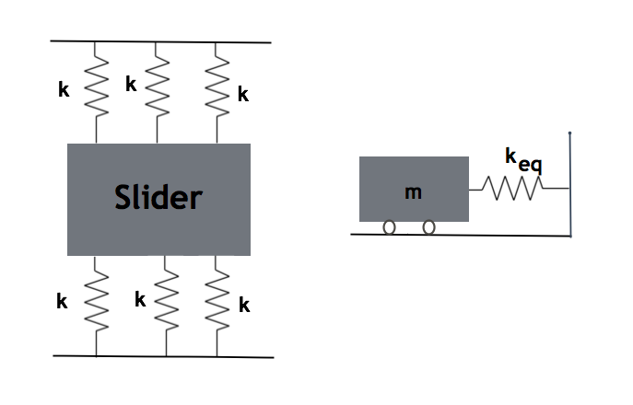Obtain the equations of motion using Newton’s Laws of Motion:

|  |  |
| --- | --- |
| m= |  |
| k= |  |
| c= |  |

1. Find the transfer function assuming an input force is applied to the system:

**Free Response Using Matlab**

Create Matlab Simulink model only for the compliant mechanism both using equations of motion and transfer function and compare the results with the experimental data.

**Critical Thinking Questions**

Answer the following questions briefly.

1. What is the stiffness of single flexible beam in the compliant vibratory mechanism?
2. In vibration analysis, can damping always be disregarded? Does damping have an effect on natural frequency?
3. How do you connect several springs to increase the equivalent stiffness? What is one example from industry or other real-life situations where this occurs?
4. What causes decay in the amplitudes of vibration in both setups?

**Reflection Questions**

1. What are the three most important concepts that you have learned in this lab?
2. What was the muddiest point remaining that you haven’t yet mastered? Write out one question you can ask your instructor to clear this up.
3. How did the effort you applied to this learning activity help you succeed?